Lecture 15, October 12, 2010 (Key Points)

Role of Channel Network in the Hydrologic Response of a Basin to Precipitation

Introduction
Two broad methodologies have been developed for transforming rainfall to runoff hydrographs in river basins. The first one is called “lumped”. An Instantaneous Unit Hydrograph (IUH) is an example of a lumped approach, because it represents the response of an entire basin. The second approach is “distributed”. Its main feature is that the basin outflow hydrograph is obtained by tracking precipitation through different phases that generate runoff in a basin. A large number of distributed rainfall-runoff (RF-RO) models have been developed in the past 50 years. They are widely used by consulting companies and government agencies. We don’t intend to cover them here, because they were not suitable to understand the multi-scale behavior of hydrologic processes that transform precipitation to runoff. You would learn them in other courses that CEAE department offers.
A key question arises: How can a distributed methodology be related to a lumped methodology for a basin? For the most part an answer to this key question has remained poorly investigated and understood. There are many reasons for it that we briefly reviewed in Lecture 14 following Brutsaert (2005, pp 459-461). We will explore contemporary developments towards unifying these two sets of approaches in next several lectures starting with Lecture 15. It involves three key concepts in understanding the multiscale nature of hydrologic processes: (i) terrain and river networks, (ii) power law pattern in multi-scale flood data for RF-RO events, (iii) scale and scaling.

15.1 Geomorphologic Instantaneous Unit Hydrograph (GIUH)
Two different methods for incorporating channel network topology and geometry into an IUH have been introduced since 1976. Both are known as a geomorphologic IUH or GIUH. The GIUH concept was extensively investigated during the 1980s and 1990s on both empirical and theoretical grounds.
The first GIUH is based on the concept of a width function (Kirkby 1976). It is explained below. The width function is also covered in Brutsaert (2005, pp. 482-483). The second GIUH uses Strahler ordering of a network (Rodriguez- Iturbe and Valdez 1979, Gupta et al.1980). The GIUH based on Strahler ordering will not be covered here. Gupta and Waymire (J. Hydrology, 1983) compared the output from the two GIUH using an idealized example, and demonstrated that the GIUH based on Strahler ordering distorts the hydrologic response of a basin. Our plan is to explain the width function GIUH and its relationship with Clark’s IUH of engineering hydrology (Brutsaert, 2005, pp. 483-484).

15.2 Computation of GIUH from the Width Function
The width function of a network is defined as the number of links at a distance upstream from the outlet. Here, distance is measured along the channels of the network. If the link lengths are assumed to be constant then it is called the topologic width function. A topologic width function for an idealized channel network is shown in Fig. 15.1.

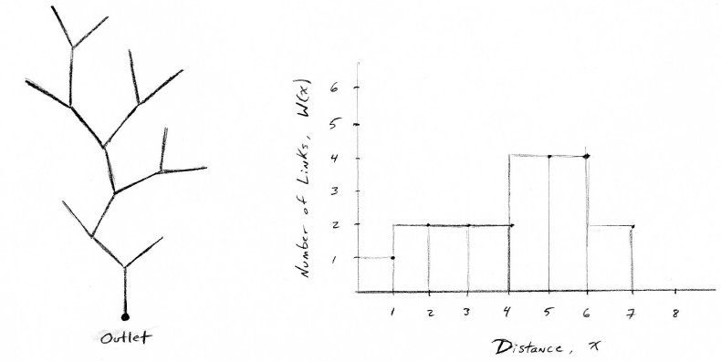
Figure 15.1 An idealized network with a common link length x (left). The width function W(x) of the network (right).

In river basins, link lengths vary spatially and randomly. Link lengths are generally assumed to come from a probability density function (pdf) (See Jarvis and Woldenberg, paper no. 8, 1984). A network with spatially variable link lengths produces a geometric width function.

Example: Use CUENCAS to find the Width Functions for GCEW

Steps to take:

1. In CUENCAS, display the GCEW DEM. Find a window on the top called “predefined outlets” and click on it. Select “basin code outlet” and click on it. The drainage divide and the outlet of the basin (with a red box) will appear on the map.
2. Option Click on the outlet red box to open a window called “Geomorphology Analysis”.
3. Click on the Geomorphology tab to open a new window.
4. Click on the Width Function tab at the top of the window. Below the tab and above the displayed plot, you will see that there are two buttons that you can activate to plot the topologic and the geometric width functions.

To understand the importance of the width function in a hydrologic context, assume that water is flowing through the network with a spatially uniform velocity,, and there is no storage in any link in the basin. Then flow distance, x and time, t are related as, . Let A_{l} denote two hillslope areas that drain a link from either side. Substituting into the width function gives the following expression for discharge in a channel network,

(15.1)

Proportionality sign incorporates spatial variations in hillslope areas.
Eq. (15.1) says that the width function, up to a scale transformation from space to time, and constants , determines the response of the channel network to an instantaneous, spatially uniform, effective (net) rainfall that becomes runoff applied on it. Therefore, the width function is proportional to a GIUH.

15.3 Comparison of Width Function GIUH with Clark’s IUH

A Brief Review of Clark’s IUH
Clark’s IUH and related concepts are explained in Brutsaert (Ch. 12.2.2, pp. 476-484, 2005). A brief review is given here for ease of a quick reference in understanding how it is connected to a GIUH.
The time-area represents outflow from an instantaneous input applied uniformly over the catchment area. One constructs a distance-area function representing areas of a basin, say at the same distance from the outlet. Then using the transformation, , a time-area function, is constructed as shown in Fig. 15.2 (a). Dashed lines in Fig. 15.2(a) represent lines of equal travel time to the outlet. Time-area function represents unit response of a basin as shown in Fig. 15.2(b).
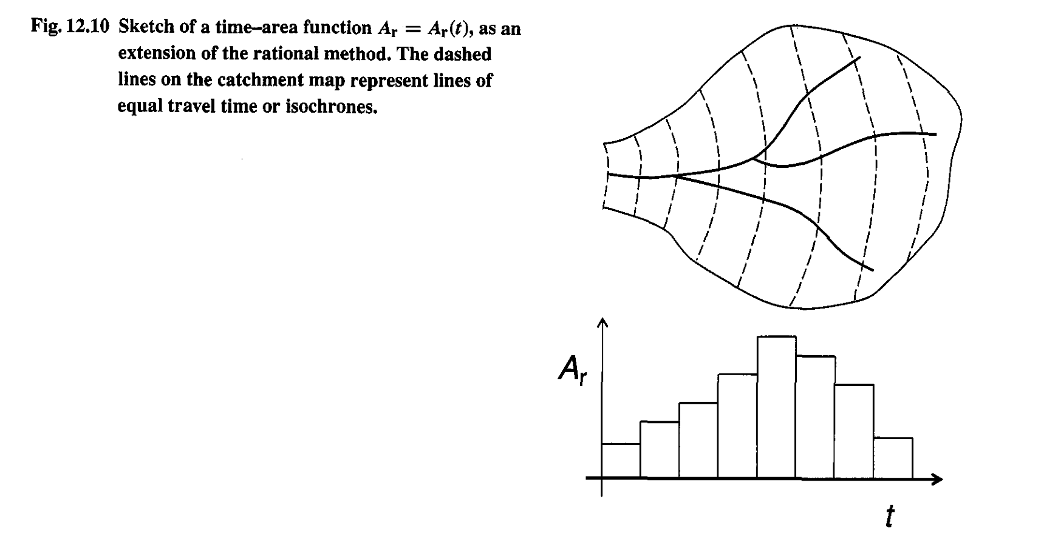
Figure 15.2(a) Time-Area function for a river Basin (Brutsaert, 2005, p.481)

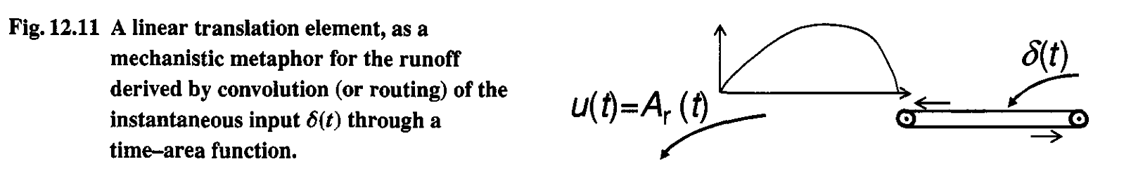

Figure 15.2(b) Time-Area function as a unit response of a basin (Brutsaert, 2005, p.481)

The shape of the time-area graph is the shape of the hydrograph at the outlet if water moves with a constant velocity v.
Main physical drawback in the time-area function approach is that it includes no storage in a basin. This drawback is corrected in the Clark’s approach by introducing a storage element through which the flow from the time-area function is routed as shown in Fig. 15.3. Discharge through a storage element, are related as,

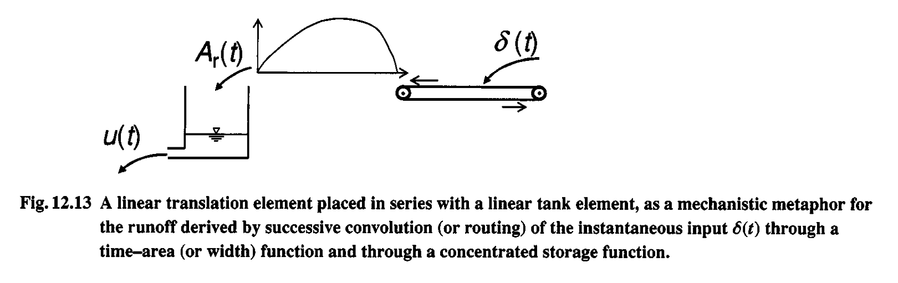
Figure 15.3 Routing Time-Area function through a storage element (Brutsaert, 2005, p.481)

, where is a storage parameter with units of [T]. To incorporate storage into time-area function approach, write the equation of mass conservation or continuity,

, or (15.2)

The solution of this non-homogeneous differential equation is,

(15.3)

Note: You are advised to review a differential equations textbook and make sure that you understand how Eq. (15.3) is a solution of Eq. (15.2). It is also known as the convolution equation.

Back to GIUH: An example

- Consider a simple network (left) and its width function (right) in Fig. 15.4(a).

- Each of the two hillslopes that make up a link is assumed to have .01 km² area (100m x 100m). Therefore, you can divide the tree into two areas: A₁=0.02 km² for the first link, and A₂=0.04 km² for the second two links (see Fig. 15.4(b)).

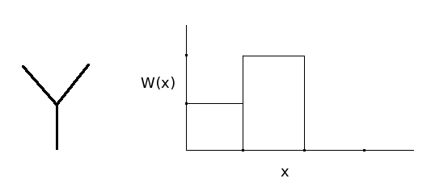
Figure 15.4 (a) A simple channel network and its width function

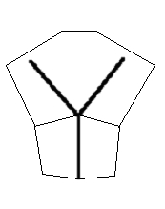
Figure 15.4 (b) Link areas associated with the channel network

- Now consider the Width-Function GIUH and Clark’s IUH for this network. Let ν=0.1 m/s be the travel time for each link, , link length = νt = 90 m, and K=30 hr. Use Eq. (15.3) to compute Clark’s IUH (HW#7)

- GIUH results are shown in Fig. 15.5. The dotted line represents the width-function GIUH. The difference between the two IUHs comes from differences in how flow is “attenuated” in a basin. In Clark’s IUH this effect is “lumped” into a storage term. As a result, discharge values are lower and flow lasts longer.

- The flow attenuation parameter K in Clark’s IUH is a “gross” parameter that can be estimated from observed hydrographs. As a result, discharge values are lower and flow lasts longer. But it begs the fundamental hydrologic question: How can the flow attenuation be understood in terms of physical processes?

- Kirkby (1976) gave a physical interpretation of flow attenuation involving GIUH formulation. We will discuss this important issue in the next lecture. In my view the importance of width function GIUH lies in making progress in answering this key question, which is not apparent from Clark’s IUH.

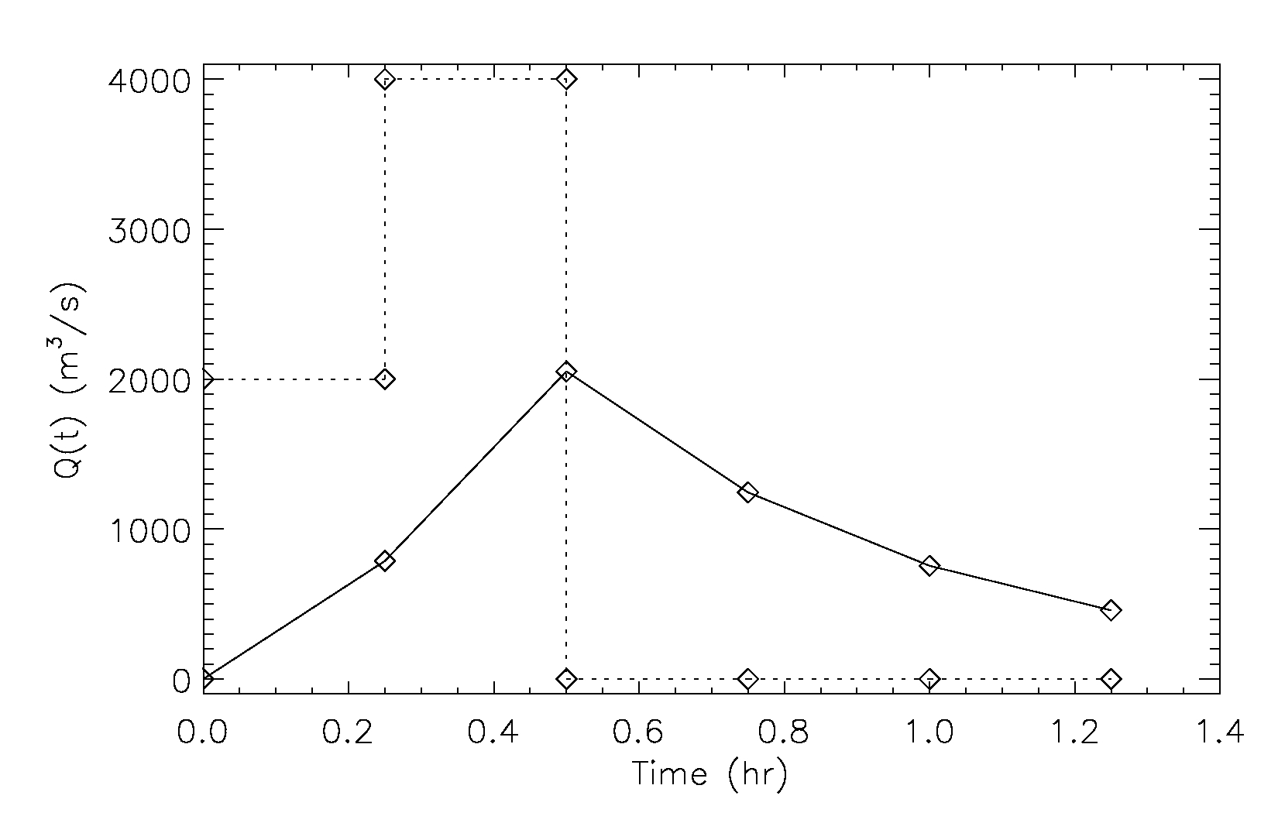
Figure 15.5 Hydrographs from the width function and Clark’s IUH

15.4 GIUH Framework to understand complexity in distributed modeling
- Open GCEW in CUENCAS as mentioned above and in Lecture 10. Click on the window on the top called “predefined outlets”. It has 18 outlets to subbasins, and all of them have stream flow gauges. For illustration, select four outlets from the list. On each outlet, click on the Geomorphology tab to open a new window, and look at the width functions corresponding to these outlets. You will notice that no two width functions look alike. This is due to spatial variability in the network branching structure, i.e., the network topology. This feature is common to all basins in the world.

- At each outlet one can calculate the time-area histogram from the network width function, and hillslope areas draining into each link. To visualize the hillslope-link decomposition of the Walnut Gulch (we have done it before). Option click on any outlet, and click on “rainfall-runoff modeling” in the window.

- Click on “hillslope-link system” on top, which shows you the hillslope-link decomposition of GCEW. The channel network is not very clear although it is there. To see the river network more clearly, click on “channel network” window.

- Repeat step 4 on each of the four outlets that you selected under item 2. You
will notice the huge spatial differences in the terrain draining into the outlets. But regardless, we can explicitly calculate the time-area histogram from the width function by assuming that the flow velocity in the network is uniform through out the basin.

- Let us consider the attenuation parameter K for each of the four outlets. Are they the same? Clearly not (why?). Therefore, the problem of estimating K for each of the 18 outlets is not a simple one. You may argue that it is possible to estimate K from stream flow data that is available at each of the 18 gauges. That is correct. But what about other subbasins of GCEW where no stream flow data is available? Such basins are called ungauged.

- Prediction of hydrologic response from ungauged basins is a major scientific and and engineering challenge.

- The issue before us is to understand and model storages and flows, both in hillslopes and in channels, in terms of physical processes!

References:

Brutsaert, W. Hydrology: An Introduction, Cambridge, 2005.

Gupta, V. K., E. Waymire, and C. T. Wang, 1980: A representation of an instantaneous unit hydrograph from geomorphology. Water Resour. Res., 16(5):855-862.

Gupta V. K., and E. Waymire, 1983: On the formulation of an analytical approach to hydrologic response and similarity at the basin scale, In: Scale Problems in Hydrology, (Ed. I. Rodriguez-Iturbe and V. Gupta), J. Hydrology, 65: 95-123.

Kirkby, M.J. (1976): Tests of the random network model, and its application to basin hydrology, Earth Surf. Processes, 1, 197-212.

Rodriguez-Iturbe, I., and J. B. Valdez, 1979: The geomorphologic structure of hydrologic response, Water Resour. Res., 15(6), 1409-1420.

